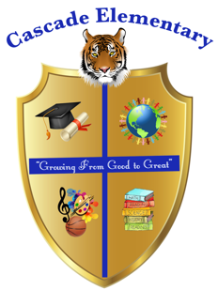

Cascade Elementary Website
Weekly Grade Level News Blast

Week of: May 11, 2020

Grade Level: Kindergarten
Jelks, Jackson and Stephens

Standards of the Week: Review Standards
ELA: RL1. With prompting and support, ask and answer questions about key details in a text.
Supporting Standard

RL3. With prompting and support, identify characters, settings, and major events in a story.
Writing-use drawing, dictating, and writing to compose opinion pieces

Math- MGSEK.OA.1 Represent addition and subtraction with objects, fingers, mental images, drawings, sounds (e.g., claps), acting out situations, verbal explanations, expressions, or equations

Social Studies – SSKH2 Identify the following American symbols:
a. The national and state b. Pledge of Allegiance
c. Star Spangled Banner d. The bald eagle
e. The Statue of Liberty
Presidents Day and the current president)

Science -SWBAT describe physical attributes of rocks IOT classify rocks based on their characteristics.
Additional Information for Parents and Students:
Zoom Lesson
Monday- Thursday
Jelks- 8:30-9:00am ( ELA)
Jackson- 9:30- 10:00 ( Math)
Stephen- 11:00- 11:30 ( Science/ Social Studies)

